**Ghana country profile**

Published

1 May 2018

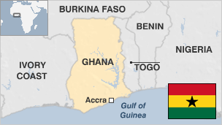

**Ghana is considered one of the more stable countries in West Africa since its transition to multi-party democracy in 1992.**

Formerly known as the Gold Coast, Ghana gained independence from Britain in 1957, becoming the first sub-Saharan nation to break free from colonial rule.

Gold, cocoa and more recently oil form the cornerstone of Ghana's economy and have helped fuel an economic boom.

The country is named after the great medieval trading empire that was located northwest of the modern-day state until its demise in the 13th century.

* Read more [country profiles](http://news.bbc.co.uk/1/hi/country_profiles/) - Profiles by [BBC Monitoring](http://bbc.co.uk/monitoring)

**President: Nana Akufo-Addo**

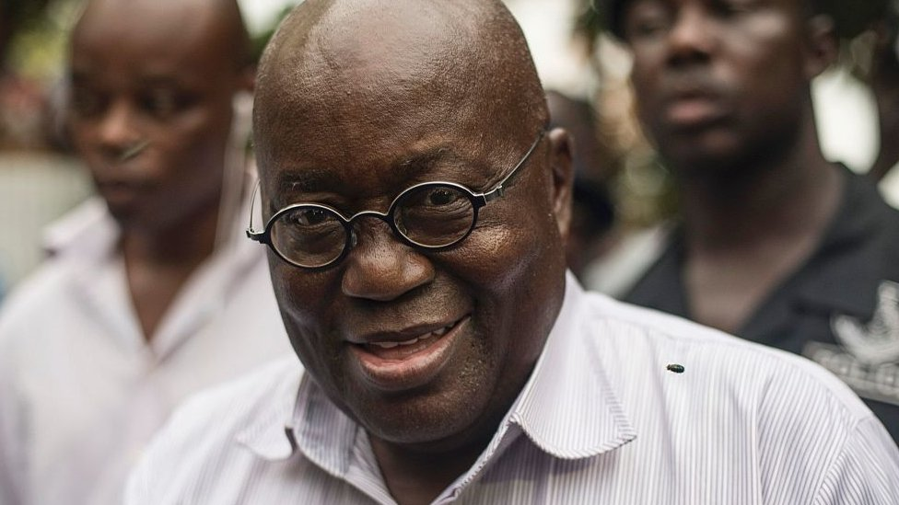image copyrightGetty Images

Nana Akufo-Addo won the presidential election in December 2016, tapping into an electorate fed up with a sputtering economy and ready for change.

The erudite 72-year-old human rights lawyer won 53.8% of the vote, according to the country's election agency, and incumbent John Mahama conceded defeat after a hotly contested race that was seen as a test of the country's democracy in a region plagued by dictators and coups.

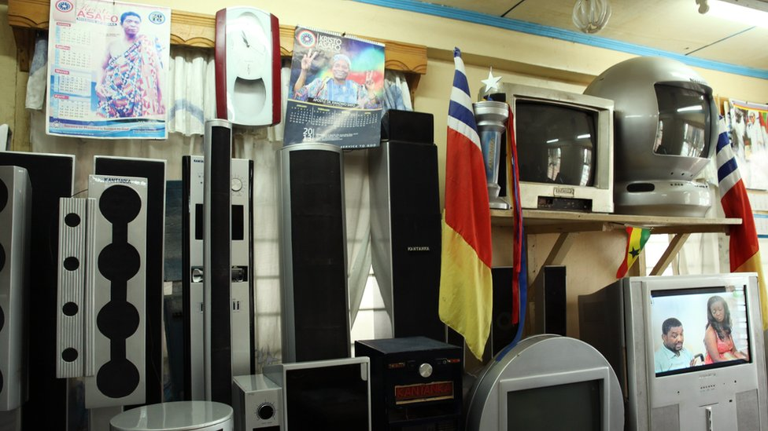image copyrightGetty Images

image captionThe Apostle Safo Technology Research Centre aims to transform Ghana's manufacturing sector

Ghana enjoys a high degree of media freedom, and the private press and broadcasters operate without significant restrictions.

Radio is Ghana's most popular medium, although it is being challenged by increased access to TV.

# Ghana profile - Timeline

Published

1 May 2018

## A chronology of key events:

**12th century -** Various states established by the Akan people emerge and develop the gold trade.

**1482** - Portuguese and later other European states set up posts to trade gold with the various Akan states.

**1874** - British proclaim coastal area a crown colony.

**Late 1400s - mid-1800s** - Millions of West Africans are captured and sent as slaves to the Americas and the Caribbean.

**1925** - First legislative council elections take place.

**1948** - Rioting after British colonial police kill three Ghanaian Second World War veterans during a protest march demanding compensation for their war service. It becomes a milestone in Ghana's struggle for independence.

**1957** - Independence for the state now called Ghana, the first country in black sub-Saharan Africa to shake off colonial rule, inspiring liberation struggles around the continent. Kwame Nkrumah is prime minister.

**1960** - Ghana proclaimed a republic; Nkrumah elected president.

**1964** - Ghana becomes a one-party state.

**1966** - Nkrumah overthrown in military coup; Russian and Chinese technicians expelled.

**1969** - New constitution facilitates transfer of power to civilian government led by Kofi Busia.

**1972** - Mr Busia ousted in military coup led by Colonel Ignatius Acheampong.

**1978** - Colonel Acheampong forced to resign; General Frederick Akuffo takes over.

## Rawlings era

**1979** - General Akuffo deposed in coup led by Flight Lieutenant Jerry Rawlings. He and former leader Ignatius Acheampong are executed.

**1979** September - Lt Rawlings hands over power to an elected president, Hilla Limann.

**1981** - President Limann ousted in military coup led by Lt Rawlings after two years of weak government and economic stagnation.

**1983** - Lt Rawlings adopts free-market economic policies, abolishing subsidies and price controls, privatising many state enterprises and devaluing the currency.

**1992** - Referendum approves new constitution introducing a multiparty system. Lt Rawlings elected president.

**1994** - One thousand people are killed and a further 150,000 are displaced in the Northern Region following ethnic clashes between the Konkomba and the Nanumba over land ownership.

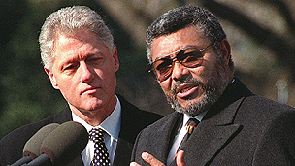

image captionJerry Rawlings, r, seen with US President Bill Clinton, came to power in a coup but won subsequent elections

## Kufuor elected

**2000** - December - John Kufuor beats Vice-President John Atta Mills in the presidential election.

**2001** February - Petrol prices rise by 60% following the government's decision to remove fuel subsidies.

**2001** April - Ghana accepts debt relief under a scheme designed by the World Bank and the IMF.

**2002** April - State of emergency is declared in the north after a tribal chief and more than 30 others are killed in clan violence. State of emergency is lifted in August 2004.

**2003** October - Government approves merger of two gold-mining firms, creating new gold-mining giant.

## Oil discovered

**2007** June - Major off-shore oil discovery announced. President Kufuor says oil will turn Ghana into an "African tiger".

**2007** September - The worst floods for more than 30 years cause widespread devastation, destroying much of the annual harvest.

**2008** December - John Atta Mills elected president.

**2009** July - Ghana secures a $600m three-year loan from the International Monetary Fund.

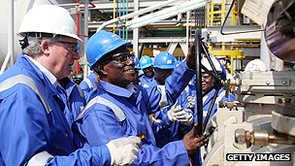image copyrightGetty Images

image captionPresident Mills ceremonially launches Ghana's oil production

**2010** December - Offshore oil production begins.

**2011** July - President John Atta Mills chosen as ruling National Democratic Congress party's candidate for the 2012 presidential election, defeating Nana Konadu Agyemang-Rawlings, wife of former President Jerry Rawlings.

**2012** June - Thousands are displaced by communal violence in the east, sparked by the exhumation of the body of a Muslim cleric.

**2012** July - President Mills dies, and is succeeded by John Mahama.

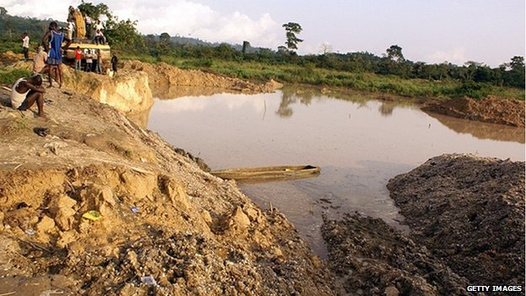image copyrightGetty Images

image captionOne of Ghana's many informal gold mines

**2013** Authorities arrest hundreds of Chinese and other migrants are working in unlicensed gold mines. The government says around 4,700 illegal miners, most of them Chinese, were deported in 2013.

**2014** July - Thousands take to the streets to protest against the government's alleged mishandling of the economy.

**2015** December - Twenty judges are sacked after being implicated in a high-profile bribe-taking scandal.

**2017** January - Opposition candidate Nana Akufo-Addo sworn in as president after beating incumbent John Mahama in previous month's election, fought mainly on country's faltering economic performance.

**2017** October - Ghana and Ivory Coast set up a commission to implement an international ruling on a maritime border dispute involving oilfields.